December 14, 2015
For more information
contact:

Todd Stepanuik
MHA President & CEO
519-245-5295 #5592

or visit our website:
www.mhalliance.on.ca

MEDIA RELEASE

For Immediate Release
FCHS completes $700,000 renovation; X-ray suite resumes regular operations

(Newbury, ON) – December 7th, 2015 marked the completion of an extensive renovation of the Four Counties Health Services (FCHS) X-Ray suite. Over a period of six weeks, the entire room has been renovated and refurbished with state-of-the-art, automated equipment. Currently there are 6 of these units in Canada, with 5 being installed in hospitals. Now our patients will have access to the best technology available and will experience full accessibility, superior quality imaging and faster examination times - all with enhanced safety providing healthcare close to home.

“FCHS is excited to resume regular operations and offer our patients the best possible care in terms of X-ray imaging,” says Steph Ouellet, VP Strategic Partnerships and FCHS Site Director.

As an integral part of the renewed vision for patient care at FCHS, this renovation has been made a reality as a result of the successful fundraising efforts of the FCHS Foundation, and the generous individual, municipal, and corporate donations it received from the community.

“FCHS Foundation is pleased to have contributed to the addition of this wonderful resource for our community”, says Paula Downs, FCHS Foundation Board Chair.

“The new Diagnostic Imaging Suite at FCHS, complete with state of the art x-ray equipment is the beginning of a new era for x-ray capabilities at FCHS and is a shining example of how we are continuing to invest in FCHS and provide service that is second to none for our patients closer to home,” says Todd Stepanuik, President and CEO of Middlesex Hospital Alliance.

A celebration event at FCHS to formally mark the suite’s grand re-opening will be held on January 13th, 2016, and the general public will be able to participate in an Open House / Tour from 2:30 p.m. to 4 p.m. to view the new suite and equipment.
About MHA:
The Middlesex Hospital Alliance (MHA) is comprised of two fully-accredited partner sites: Four Counties Health Services and Strathroy Middlesex General Hospital.

A progressive, team-oriented and technologically adept organization of excellence, the MHA is creating a more integrated and seamless approach to treatment by embracing and seeking out partnerships, through collaboration and investing in people. This coordinated approach helps to ensure that a high level of service is provided while reducing costs and continually enhancing quality.

Providing core acute primary and secondary hospital care, the MHA has also been recognized for establishing two notable Centres of Achievement (Orthopaedics and Diabetes Education Centre) that generate local and regional referrals.

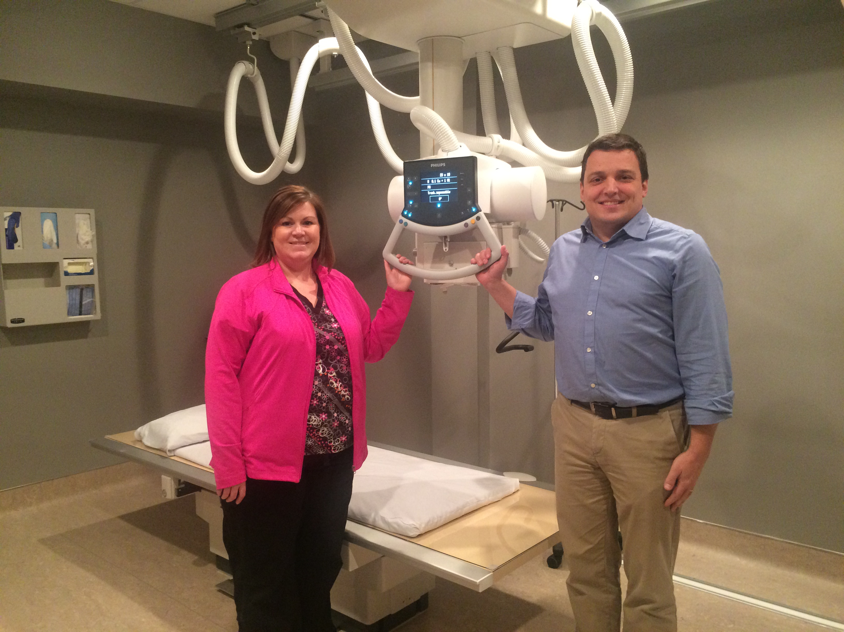

Photo includes; Laura James, Team Leader, FCHS Diagnostic Imaging and Steph Ouellet MHA V.P. of Strategic Partnerships and FCHS Site Director.

