April 1, 2016
For more information
contact:

Todd Stepanuik
MHA President & CEO
519-245-5295 #5592

or visit our website:
www.mhalliance.on.ca

MEDIA RELEASE

Respirology Rehab Clinic expands at FCHS

For Immediate Release
(Newbury, ON) –Four Counties Health Services (FCHS), part of the Middlesex Hospital Alliance, has expanded its Respirology Rehabilitation Clinic through the use of technology supported by the Ontario Telemedicine Network (OTN).

The hospital, in collaboration with Sarnia-based respirologist Dr. Gautam Soparkar, will now conduct “virtual” clinic visits with the use of videoconference equipment, leveraging digital stethoscope technology.

The introduction of this digital stethoscope seamlessly relays a patient’s heart and breath sounds and allows Dr. Soparkar to provide care from his clinic in Sarnia to patients in Newbury with the support of nurse practitioner Lesa Marsh. The digital stethoscope can seamlessly relay heartbeat and breathing sounds across a secure network, allowing Dr. Soparkar and Lesa Marsh, FCHS Nurse Practitioner, to jointly assess and discuss care with the patient.

Lesa Marsh, stated, “Patients are very positive, inquisitive and appreciative that these services can be maintained close to home.” Currently this clinic is offered monthly and is able to accommodate up to 12 patients per clinic day.

“I am very satisfied with the service provided at Four Counties Health Services. It saves me time with an unnecessary trip into London,” said Mr. James Sawyer, the clinic’s first virtual patient.

Dr. Ed Brown, CEO of OTN, said the clinic provides the right care in the right place at the right time, a priority for a transformed healthcare system in Ontario. “Virtual medicine is the future of patient-centred health care. Congratulations to Four Counties Health Services for taking this important step.”

“This program is another example of the renewed vision for patient care at FCHS and our commitment to provide care for our patients closer to home. Congratulations to the project team for this successful accomplishment.” says Todd Stepanuik, MHA President & CEO.

About MHA:
The Middlesex Hospital Alliance (MHA) is comprised of two fully-accredited partner sites: Four Counties Health Services and Strathroy Middlesex General Hospital.

A progressive, team-oriented and technologically adept organization of excellence, the MHA is creating a more integrated and seamless approach to treatment by embracing and seeking out partnerships, through collaboration and investing in people. This coordinated approach helps to ensure that a high level of service is provided while reducing costs and continually enhancing quality.

Providing core acute primary and secondary hospital care, the MHA has also been recognized for establishing two notable Centres of Achievement (Orthopaedics and Diabetes Education Centre) that generate local and regional referrals.

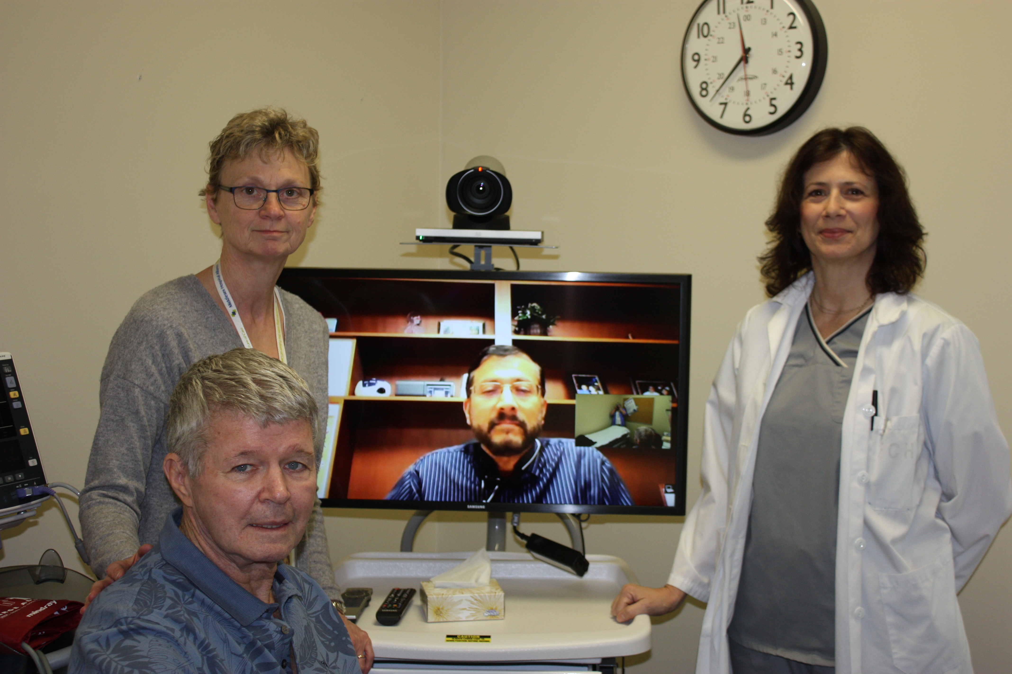
Respirology Rehab Clinic patient, Mr. James Sawyer, standing left to right Lesa Marsh, Nurse Practitioner, Dr. Gautam Soparkar shown on video screen and Tammy Turbide, RPN.

