February 25, 2015
For more information
contact:
Todd Stepanuik
President & CEO
519 245-5295, #5592
or visit our website:
www.mhalliance.on.ca

MEDIA RELEASE
For Immediate Release

SMGH Commences Hospital External Re-cladding
(Strathroy, ON) – Over the next several months, Strathroy Middlesex General Hospital will undergo a major change in its external appearance. Nicholson Sheffield Architects Inc are responsible for the new façade designs while K&L Construction (Ontario) Ltd and Ontario Panelization will be installing the new cladding. The first phase is the installation of a new vapour permeable air barrier to prevent exterior moisture from entering the existing brick façade. The new cladding materials will be mounted on a structural grid system which supports three new exterior cladding materials: aluminum composite wall panel system, porcelain ceramic panel system and a clay tile wall panel system. This will prevent further damage to the exterior brick of the 1962 and 1972 building, provide an additional water seal, improve energy efficiency as well as a brand new look to the approximately 39,000 exterior square feet of SMGH.

During this project, workers will be utilizing man lifts and will be outside on various levels of the building. Hospital staff will ensure patient room blinds are closed in the necessary areas to allow the privacy of patients. Although this is an external project, there will still be the regular construction noises such as drilling into the brick. All entrances and exits will remain open and safely secured. We apologize for any inconvenience resulting from the re-cladding project.

As previously announced, this $2.4M project is funded by the 2014/15 and 2015/16 provincial Health Infrastructure Renewal Funding (HIRF) allocation. Architectural drawings and product samples will be on display by mid March in various locations in the hospital.

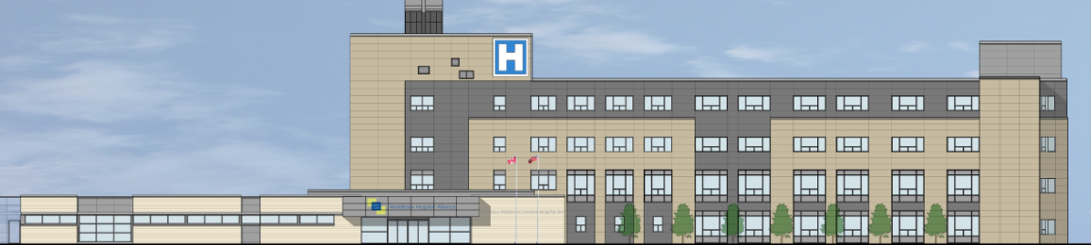

About MHA:
The Middlesex Hospital Alliance (MHA) is comprised of two fully-accredited partner sites: Four Counties Health Services and Strathroy Middlesex General Hospital.

A progressive, team-oriented and technologically adept organization of excellence, the MHA is creating a more integrated and seamless approach to treatment by embracing and seeking out partnerships, through collaboration and investing in people. This coordinated approach helps to ensure that a high level of service is provided while reducing costs and continually enhancing quality.

Providing core acute primary and secondary hospital care, the MHA has also been recognized for establishing two notable Centres of Achievement (Orthopaedics and Diabetes Education Centre) that generate local and regional referrals.

- 30 -

